1. **GIT_HOL**

**Objectives**

This hands-on lab was performed to gain practical knowledge of the following Git concepts:

* Basic Git commands: git init, git status, git add, git commit, git push, git pull
* Git configuration setup on a local machine
* Integration of Notepad++ as the default Git editor
* Tracking and managing files in a local Git repository
* Pushing local repository changes to GitHub

**Prerequisites**

* Git Bash client installed on the local machine
* Notepad++ installed
* GitHub account created (used instead of GitLab for this exercise)
* Repository cloned: [Cognizant_DNassignments_hands_on](https://github.com/shreeshainiha-js/Cognizant_DNassignments_hands_on)

**Step 1: Git Configuration**

1. **Check Git installation:**



1. **Set user configuration:**



1. **Verify configuration:**

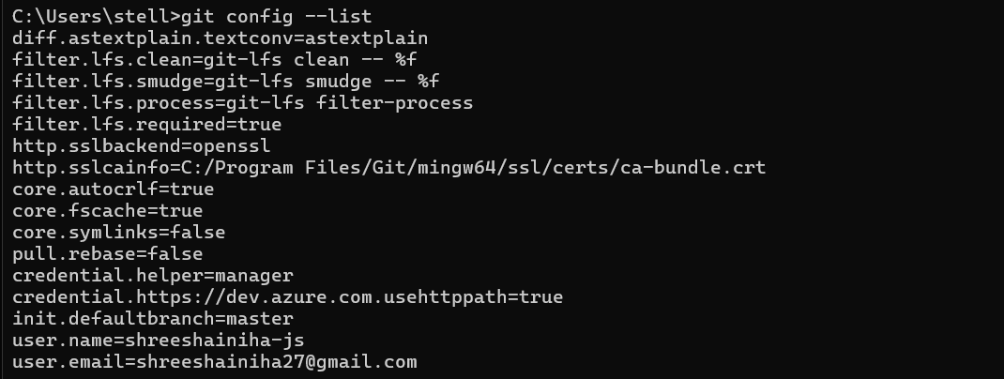

**Step 2: Integrate Notepad++ as Default Git Editor**

1. **Check Notepad++ availability from Git Bash and Set Notepad++ as default editor:**

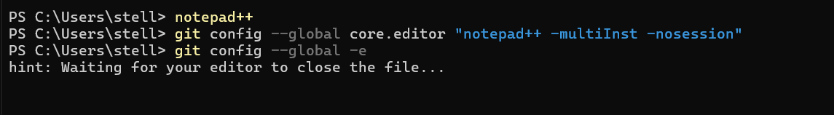

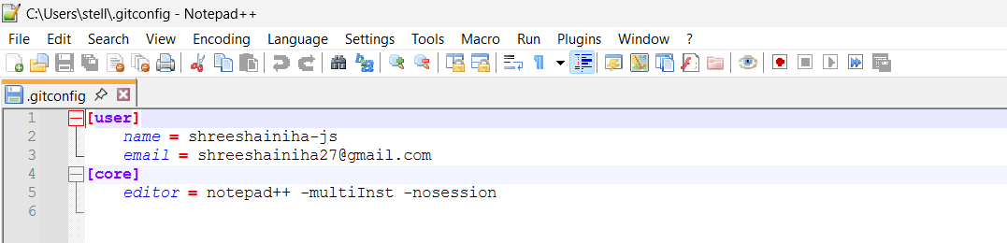

**Step 3: Create & Manage Git Repository**

1. Navigate to Week_8_GIT folder and create project directory:



1. Initialize Git repository:



1. Create file and add content:



1. Check Git status:

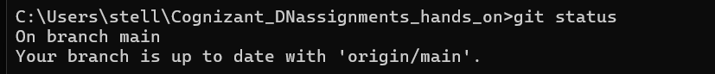

1. Track and commit the file:

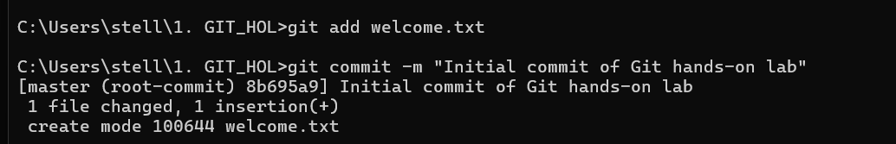

1. Check final status:

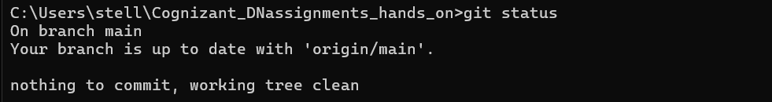

**Step 4: Push to GitHub Repository**

